SUSANNA SOOJUNG LIM
Russian, East European, and Eurasian Studies
East Asian Languages and Literatures (Korean Studies)
Home address: 3724 Colony Oaks Drive, Eugene, OR, 97405
Departmental address: 418 Friendly Hall, University of Oregon, Eugene, OR
susannal@uoregon.edu / 541-228-8487 (mobile)
___________________________________________________________________________

EMPLOYMENT
2018-present Associate Professor, University of Oregon, Russian, East European, and Eurasian
Studies (REEES) and East Asian Languages and Literatures (EALL)
2013-2018 Associate Professor, Robert Clark Honors College, University of Oregon
2007-2013 Assistant Professor, Robert Clark Honors College, University of Oregon
2006-2007 Visiting Assistant Professor, Russian Studies, Wheaton College, MA

EDUCATION
2006 Ph.D., Slavic Languages and Literatures, University of California, Los Angeles
1999 M.A., Russian language and literature, Korea University (Seoul, Korea)
1997 B.A., Russian language and literature, Korea University (Seoul, Korea)
1995 Moscow State University-Korea University Student Exchange Program

WORK IN PROGRESS
Book
Racing the Subempire: Race, Developmentalism, and Global Modernity in South Korean Culture

This project was selected as one of two institutional (UO) nominees for the 2024 NEH Summer Stipend (result to be announced April 2024)

Article
Under review
“Bad Boss: Capitalist Realism and Racial Capitalism in Squid Game,” PMLA

Invited
“Race in Putin’s Russia,” in PMLA (Publications of the Modern Languages Association)
(Special Features Cluster: “Race, Racialization, and Whiteness Before and After the Invention of
Race”) (forthcoming October 2025)

PUBLICATIONS
Book
China and Japan in the Russian Imagination, 1685-1922: To the Ends of the Orient (Routledge, 2013)

Refereed Articles and Book Chapters
“Dual Homeland: Cho Myŏng-hŭi and the Origins of Koryŏ Saram Literature,”
in Korean Studies Journal (Volume 46, 2022).

“Occidental Bullyism? Russia, Yun Ch’iho, and Race in the Early Twentieth-Century Pacific” in
Ideologies of Race: Imperial Russia and the Soviet Union in Global Context, (ed. David
Rainbow, McGill-Queen’s University Press) (September 2019).

“Wrestling with Japan: The Colonial Legacy and the Construction of National Identity in Pak
Kyongni’s Toji (Land),” in Review of Korean Studies (v. 22, n.1, June 2019), pp. 259-284.

“Singing Katyusha: Tolstoy’s Resurrection in 1910s Korea,” in Journal of Korean Studies (v.
24, n.1, March 2019), pp. 97-125.

“Whose Orient Is It?: Frigate Pallada and Ivan Goncharov’s Voyage to the Far East,” in
Nineteenth-Century Literature Criticism: Excerpts from Criticism of the Works of Nineteenth-
Century Novelists, Poets, Playwrights, Short-Story Writers, & Other Creative Writers, Gale:
2017 (Reprint)

“Pan-Mongolians at Twilight: East Asia and Race in Russian Modernism, 1890-1921” in Race
and Racism in Modern East Asia: Western and Eastern Constructions, Leiden: Brill, 2012,
pp. 153-175.

Conference Papers (selected)
“Singing Katiusha: Tolstoy’s Resurrection in 1910s Korea” presented at the Association for Slavic, East European, and Eurasian Studies (ASEEES) annual conference, San Francisco, CA
(November 23-26, 2019).

TEACHING
Russian Studies
RUSS 360: “Race in Russia and America” (S 2023, W 2024)
RUSS 410 (510): Identities in the Russian World: Thirty Years Since the Collapse” (F 2021)
RUSS 410 (510): “Women’s Writing in Russian and Slavic Literature” (F 2020, W 2024)

Korean Studies
KRN 199: “Race in South Korea: An Historical and Cultural Survey from the Colonial Period
to the Present” (S 2022, F 2023, S 2024)
KRN 410/510: “Colonialism and Nationalism in Modern South Korea, 1910s-2010s”
(F 2019)
KRN 399: “Imagining Modern South Korea” (S 2015)
KRN 199: “Imagining Modern South Korea” (S 2013)

RECOGNITION & AWARDS
2014 Translation Grant Literature Translation Institute of Korea (translation of the novel My
Uncle Bruce Lee by Cheon Myong-gwan)
2009-2010 Oregon Humanities Center Faculty Research Fellowship
Ernest G. Moll Research Fellowship in Literary Studies
2009 University of Oregon Summer Research Award
  - University of Oregon New Junior Faculty Award, University of Oregon
Susanna Lim 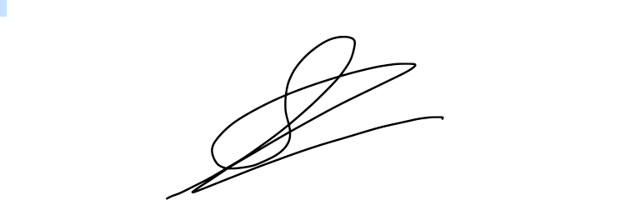11/21/2023

