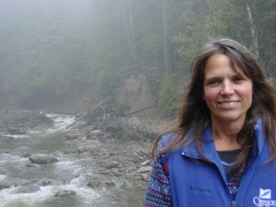
Kim Carson

Student Services Specialist

email: kcarson@uoregon.edu, archadvisor@uoregon.edu
phone: (541) 346-8039
office: 210 Lawrence Hall

M.A. UNM Albuquerque, NM 1987
B.F.A. UW Whitewater, WI 1981

Kim comes to The School of Architecture and Environment from University of Oregon’s (UO) Office of Sustainability and Oregon State University’s (OSU) Oregon Climate Change Research Institute. With over a decade of co-curricular development and implementation, she has done previous work in the Eugene area as the Mid-Willamette Valley education coordinator for The Freshwater Trust. She graduated with an MA in Art Education from University of New Mexico where she was introduced to permaculture and adobe home construction within a high desert ecosystem. This began a commitment to the future of sustainability, conservation and water scarcity. She is currently working on obtaining her Permaculture Certification through OSU to apply these concepts to her Willamette Valley 50-acre farm, which houses a solar array on her newly constructed pole barn. She is developing a Limited Liability Corporation, Sustaining Farms, where she will support tiny house construction and sustainable farming. She looks forward to applying her previous design education and sustainability work experience to her new position in academic advising and student support.

